I would like to become a businessman to be able to manage my own company. I will open up a store and maintain it by hiring employees and managers that I fill have the work ethics to work in my business. I choose to research this business because I would like to run my own business. I wouldn’t like to work for others when I get older. I fill that I fit the requirements needed to become a businessman.
I know I want to become a businessman because I like money. I don’t like minimum wage. There really isn’t a certain pay you can make. I also like it because you can’t get fired or replace in this business. It also requires a college education.
Business has been around seen the beginning of time. Before there was a type of currency. People began to trades goods. If someone wanted something someone else had they would trade for it. Quickly this spread and took off which is known today as business.
Manage is a group of people getting together to accomplish a goal. This happened since the beginning of human life. If someone needed something done they would do it threw others. Business is an organization engaged in the trade and services. This is basically the task that is being accomplished.
Business has also been around since the beginning of time. Both business and management grew threw technology. As technology grew people open stores to manage the product they are selling. Like pizza stores have businessmen to hire delivery boys to take the food to you. This is both business and management.
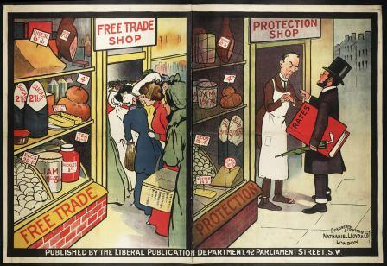
For training you will need a bachelor’s degree from college. You will receive this if you have been to college for four semesters. This may cost anywhere from four thousand to six thousand dollars per semester. So you total cost would be anywhere between sixteen thousand to twenty-four thousand dollars pending on the college you want to go to. The better the college the more money it will cost to get in.
When starting in managing your own business you start of from anywhere between fifty thousand to seventhly thousand dollars. The highest average wage for this job is around one hundred thousand dollars. If you progress and get better at this job you be a billionaire. You have to be able to market you brand. You have to be able to spread locally threw out the world and be creative.
The income is both compare and contrast to the educational cost. The education cost is much lower than the starting and higher income. Meanwhile both wages may vary, they both depend on you. If you are look for a college that does major in business management than you education cost will be low, but if you are looking for a good college that both major in business and management than your education cost will be high. Same with income if you are not that good at business or management you income will stay low, but if you are creative and hard working you income will increase.
I was also interested in being a sports competitor which is like coaching a team. They make around fourthly thousand dollars. The other career was a producer which makes around sixty thousand. Both careers are also varying on the talent you have towards that goal. This means if you work hard you get paid more.
For business management you need to have an eye on what the people want. You have to be daring make decision that will make your career lift off and be successful. You have to be patient because in business good things don’t happen instantly you have to work towards it and you have to be sociable so you can sell your business to your customers. You have to been a hard worker that is dedicated to this job and not willing to take no for an answer. You will need to be able to work with other and deal with competition.
In this career it takes a lot of energy and time. You will have to be able to travel to tell other about your business. You will have to listen to customers to see if you meeting their standards. You are in charge of your own company and outside you workplace you just have to expand the word. You have to tell them about your business or put the word out.
Again you will need a bachelor’s degree. Education of business and management is needed. You will need profession in business and management as well. You will need to know what you doing in business and management.

I’ve learn that business is like its own world it have it own way. Money is like the language because that is how they communicate. With goods being delivered it make it easy for the customer to get their going. Technology helped it to become that way. For examples Steve Jobs made it so you can read and get on the internet wherever you are.
Business haves it own laws and rules we have to know in order to become a businessman. I will be able to learn when I go to college. This tells me that business management study is not going to be easy. If I push hard and try I know I could get threw it. I need to be creative and as open minded as I can in order to succeed in this career.

