Navy SEAL
The career is researching is a Navy SEAL. This job is in the Navy branch of the military. Being a Navy SEAL is more than just having the title. It’s about being 1 of the most special ops military people in the world. To be a SEAL is being the best of the best.
I am interested in this because want to go to the military and be in the fight and be the best of the best at what I do. I always though being a SEAL would be fun. Then I looked into the military and was thinking about the Air Force. Then months later I realized I wanted to be on the ground in the fight, not over it. I looked into the Navy SEALs and found out I would love to do this. The training is the hardest training in the world. The reason for this is the U.S. military puts the SEAL trainee’s through the most mental stress they can.

The SEALs started in Vietnam. President John F. Kennedy-who had served in the Navy during World War II-and others in the military understood the need for unconventional warriors. The Navy created a unit that could operate from sea, air, and land-SEALs-drawing heavily from UDTs (Underwater Demolition Teams).
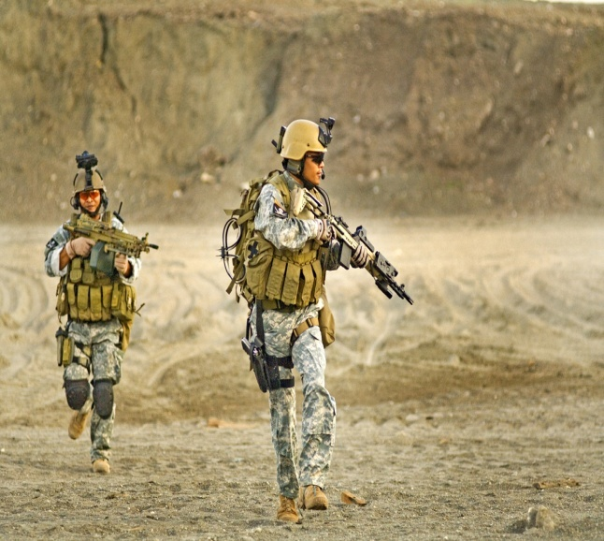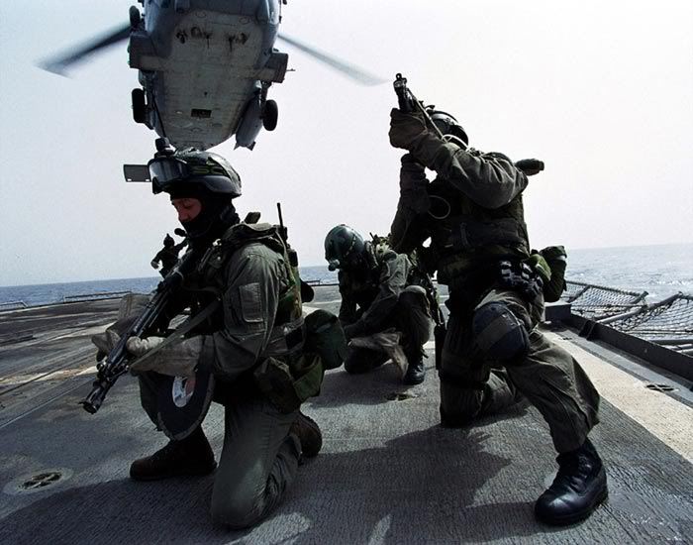
I am researching the Navy SEALs. They are a U.S. Special Forces unit. The SEALs are considered the best unit in the world.
I am interested in the Navy SEALs because I want to go into the military and thought long and hard about it. I wanted to go into the Air Force but then I thought to myself I want to be in the fight not over it. I researched in the military and the recent news of the SEALs finding and killing Osama. Then it was final I’m going to be a SEAL, having that title would be the coolest thing in the world.

The Navy SEALs was started by the U.S. in Vietnam to help us gain intelligence on where the Vietcong would attack. The U.S. now uses this elite group to do missions that would be considered dangerous for other U.S. forces. Are considered the best elite military unit in the world.
The SEALs growth was rapid; they have trained harder than ever. The SEALs training does not change much, but how they think does. The mindset the SEALs have is a growth mindset. Which means the way they think changes how they approach a problem or mission. The SEALs adapted to what is around them so they can be successful in their mission.
The SEALs have been in major historical events, and made history. They made recent history happen, the death of Osama. They also made history in Vietnam, like capturing Vietcong and getting information on where big leaders are.

I don’t expect to pay at all. To join the military you need to be a U.S. citizen. And training is free because they train you in the military, it’s called boot camp and they have more training for special jobs in the military.
The pay range depends on your rank. For an enlists fist year you can make $1,447.20 a month. And if you are a Colonel with for years in the Navy you can earn $6,776.70 a month.
For my income to be compared to the training is I will just gain money. The training is free in the military. Also for the income to be compared to other careers is the other two is game programming, and movie critic.

What I expect out of a life in this career is to have pride in my job. To be happy to say that im a Navy SEAL. For the skills for this job is mostly mental. You need to be mentally strong and not panic easily.
An open mind and ready to do whatever the mission is. You also have to be able to do whatever it takes to survive. The reasons you have to do these things are because you have a great chance of dying.
You should be able to work as a team. Be a leader. And follow orders.
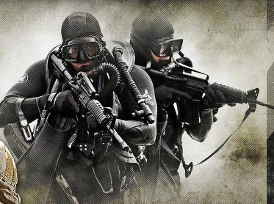

There is no normal work schedule. The schedule changes all the time. The schedule can be fine one day and the next your in combat. They have a lot of authority. They have the most respect in the Navy.
They have as much work as they are assigned. There is no real hour system. They get 30 days of payed vacation. If you did not use those days next year you can have 60 days.

I have learned that this will take a lot of time. I have learned that it’s a hard but rewarding job. It’s the most exciting job.
No it was all the same. I didn’t affect my future or anything.

