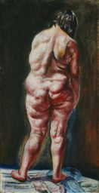
Student
Ivan Albright
2/17/12
INSECURE
Scared to turn around and face the world,
Depressed and suicidal because of judgments,
Afraid to look in the mirror because of Insecurity,
Dimples in my ass cheek I must confess,
Hardly breathing because I’m stressed,
Saggy skin, cellulite, stretch marks and all,
When I look at the scale the numbers fall,
Head hanging towards the ground,
Naked and hopeless,
TRUTH IS I’M ONLY 97 POUNDS!

http://www.artic.edu/aic/collections/citi/images/standard/WebLarge/WebImg_000072/4847_623706.jpg

