Student
2/17/2012

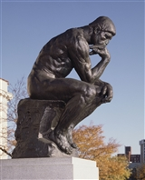

THE THINKER
BY:AUGUSTE RODIN (FRENCH, 1840-1917)

POEM
WHAT IS THERE TO DO BUT THINK?
THEY SAY IM DULL BUT WHO ARE THEY.
I AM ARTICULATE.
BECAUSE I THINK.
IN DEEP THOUGHT I SIT ALL DAY.
I DON’T CARE WHAT YOU SAY.
AND EVEN IF I DID I CANNOT SPEAK.
SOME PEOPLE SAY THAT MAKES ME WEAK.
SITTING HERE WHILE MY MIND CREEPS.
I AM THE THINKER AND IM SO UNIQUE.

